BlueDot DaaS Demo

Scenario

A client wants to show the most recent activities of Dengue, reported anywhere in the world, set refresh data interval and visualize the result on map.

Steps to demo how to use the BlueDot DaaS developer portal

To get the most recent disease activity of Dengue in the world, the developer needs to invoke “Notification” endpoint API. This can be done from any modern programming language but for the purpose of this demo and to get familiar with how to invoke the BlueDot APIs, these steps can be followed:

1. Login to <https://developer-portal.bluedot.global/> with your username and password
2. Click on BlueDot.Daas.Notification.Api
3. Click on Notification
4. Click on Try it
5. Let’s assume we want to get all the notifications for the disease activities since 2021-01-01

Here you notice that the endpoint needs startDate as mandatory input field and endDate as optional input field. So, let’s enter 2021-01-01 as we want the most disease activity of Dengue in the world.

1. Make sure the Subscription key is selected and your primary or secondary field is shown in the Ocp-Apim-Subscription-Key request header
2. Click “Try it”
3. The API will return the result in the http response after clicking Send
4. Notice that the result is all the disease activities since 2021-01-01

1. As you noticed the Notification result has diseaseId(s) but we don’t know what is the diseaseId of the Dengue disease. So, we need to get the diseaseId from BlueDot.Daas.Lookup.Api by invoking “Diseases by name” API

1. Notice that the Dengue diseaseId is 55. You will use this diseaseId to filter the Notification result later

Steps to demo how to invoke BlueDot DaaS APIs from Excel, visualize it on map and schedule the data refresh

1. Open Excel
2. From Home menu, click on “Get Data” then “From Other Sources”, the “From Web”

1. To invoke the “Notification” API from Excel, copy the API endpoint, Ocp-Apim-Subscription-Key and your key from BlueDot DaaS developer portal and place it in the Excel URL parts

1. In Excel, click “Get Data” then paste the URL of the endpoint:

1. Select Advanced and enter Ocp-Apim-Subscription-Key and your key in the header, then click OK

1. After clicking OK, the API will be invoked, and the result will appear in Excel, then click To Table and OK

1. Click on the Expand  and remove the “Use original column name as prefix” checkbox, click OK

1. The result will be shown as below. To filter Dengue only, click  on the diseaseId to select 55 to filter Dengue only, then click OK

1. The filtered result will look like this and it is showing all the notifications for the disease activities of Dengue worldwide since 2021-01-01

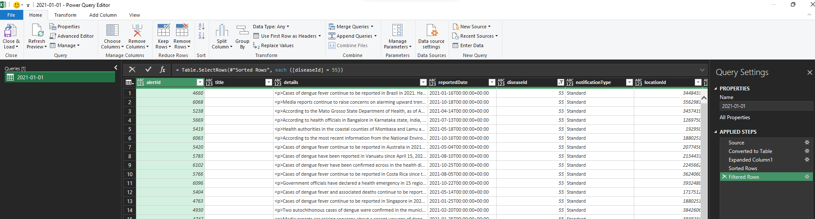

1. Click Close & Load
2. Notice the result will be loaded in a spreadsheet

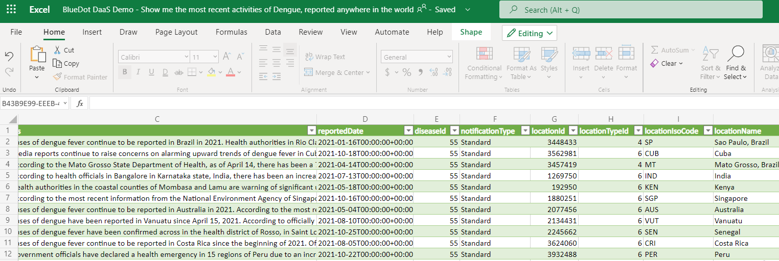

1. Let’s set Data Refresh for each 60 minutes by clicking on Connection Properties

1. Select Refresh every 60 minutes. Note that you can select any refresh period that suites you

1. Notice that Excel will invoke the BlueDot DaaS Notification API every 60 minutes and if BlueDot publish new Notification Disease Activity, the result will appear in your Excel spreadsheet
2. To visualize the result on map, you can use Excel 3D Map by clicking on Insert then 3D Map then Open 3D Map

1. The map will be shown with the filtered places in Brazil and whenever BlueDot publish new Notification for disease activity, it will appear on your map after the refresh rate that you setup above

